ANTENNAS

Antennas

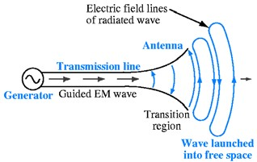• a device that provides a transition between guided electromagnetic waves in wires and electromagnetic waves in free space.

Reciprocity

• Antennas can usually handle this transition in both directions (transmitting and receiving EM waves).

This property is called **reciprocity**.

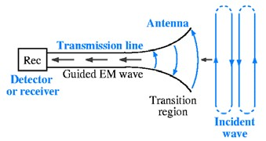

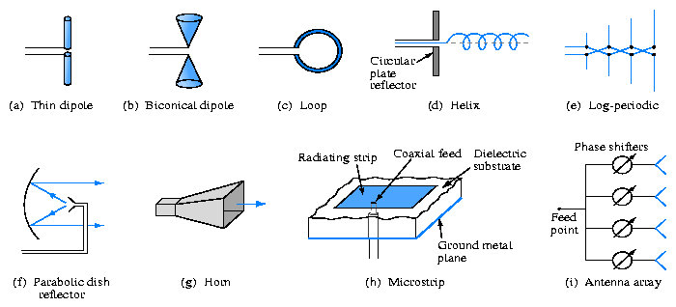• The antenna’s size and shape largely determines the frequencies it can handle and how it radiates electromagnetic waves.

Antenna polarization

• The polarization of an antenna refers to the orientation of the **electric field** it produces.

o Polarization is important because the receiving antenna should have the same polarization as the transmitting antenna to maximize received power.

• Types of Polarization

o Horizontal Polarization

o Vertical Polarization

o Circular Polarization

■ Electric and magnetic field rotate at the frequency of the transmitter

■ Used when the orientation of the receiving antenna is unknown

■ Will work for both vertical and horizontal antennas

■ Right Hand Circular Polarization (RHCP)

■ Left Hand Circular Polarization (LHCP)

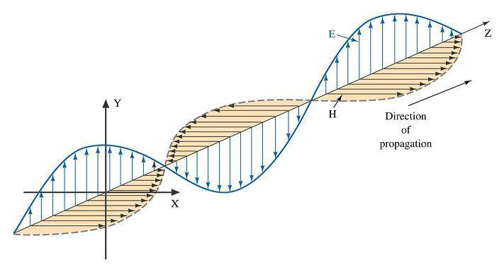 Both antennas must be the same orientation (RHCP or LHCP)

Wavelength and antennas

• recall that wavelength (λ) and frequency (*f* ) of an electromagnetic wave in free space are related by the speed of light (*c*). (*c*=3.0x108 m/s )



• The dimensions of an antenna are usually expressed in terms of **wavelength** (λ).

o Low frequencies imply long wavelengths, hence low frequency antennas are very large.

o High frequencies imply short wavelengths, hence high frequency antennas are usually small.

What to look for in Antennas?

• Frequency/Wavelength

• Beam Pattern

• Bandwidth

• Gain

Basic Antenna

• An antenna can be a length of wire, a metal rod, or a piece of metal tubing.

• Antennas radiate most effectively when their length is directly related to the wavelength of the transmitted signal.

• Most antennas have a length that is some fraction of a wavelength.

• One-half and one-quarter wavelengths are most common.

• **isotropic point source -** Power from an isotropic point source is equally distributed in all directions. It is completely **unfocused**. Antenna radiates equally in all directions.

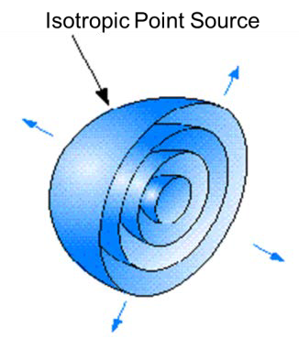

Antenna gain (*G*)

• Because an antenna is a passive device, the power radiated cannot be greater than the input power.

• The ability of an antenna to focus electro-magnetic energy is defined by its **gain**.

• Antenna gain is expressed as a ratio of the effective radiated output power (Pout ) to the input power (Pin )

• The **gain** of an antenna is a measure of power transmitted **relative** to that transmitted by an isotropic source.

• Antenna gain relative to an isotropic source is expressed in decibels as **dBi**.

Effective Radiated Power

• The **effective radiated power** (ERP or EIRP) is the gain of an antenna (with respect to an isotropic radiator) multiplied by its input power.

EIRP = Input Power x Antenna Gain

• For example, a highly directional antenna with a gain of 7 has an input power of 1-kW. Its ERP is therefore 7 kW.

Dipole Antenna

• One of the most widely used antenna types is the half-wave dipole.

• The half-wave dipole, also called a doublet, is formally known as the Hertz antenna.

• A dipole antenna is two pieces of wire, rod, or tubing that are one-quarter wavelength long at the operating resonant frequency.

Electric and Magnetic Fields around a Transmission Line

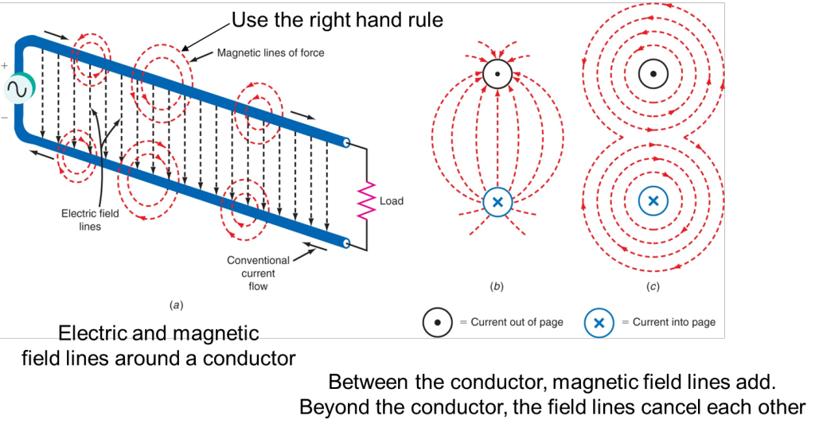

Converting a Transmission Line into an Antenna

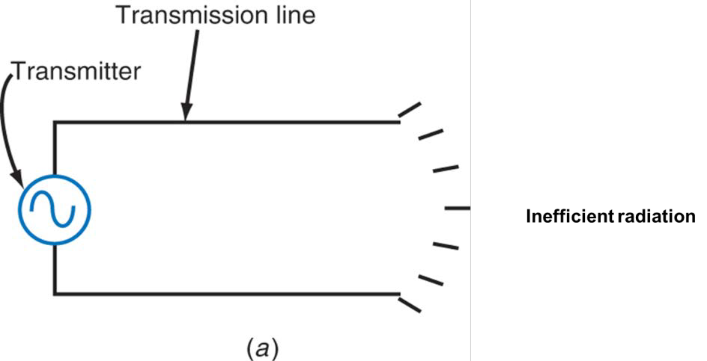

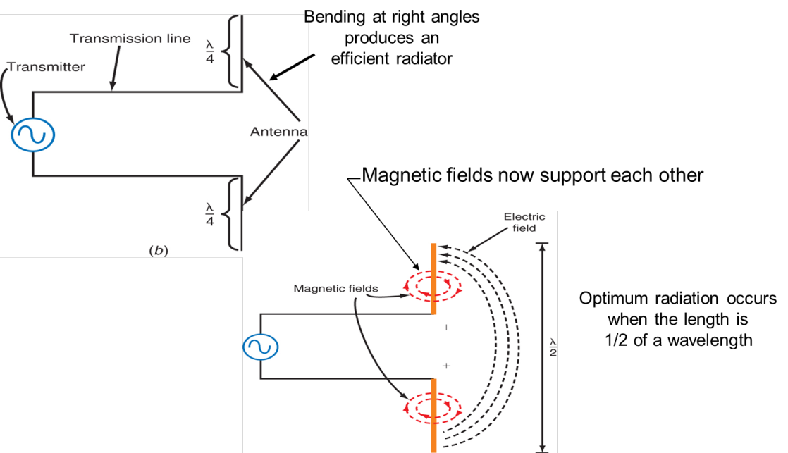

The Dipole Antenna

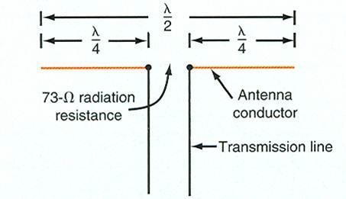

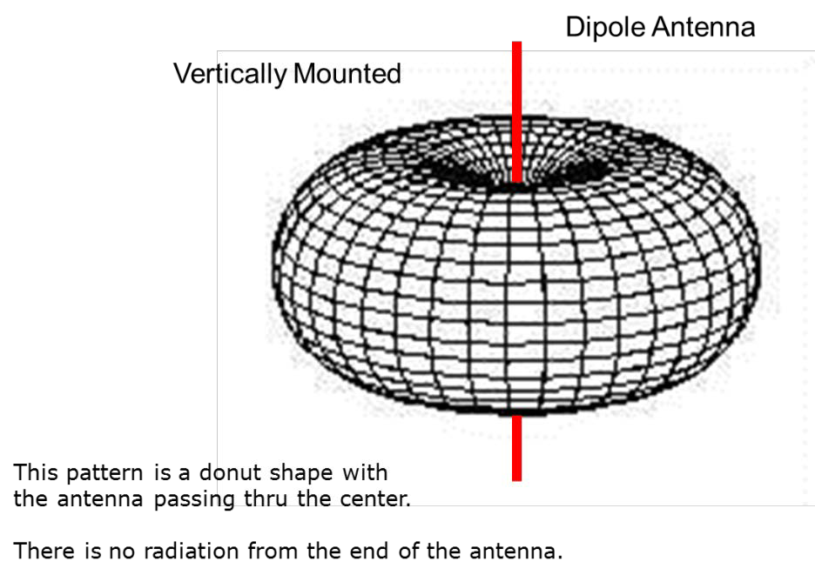Three-dimensional radiation pattern for a dipole

Antenna Losses

• Radiation Loss

o Caused by radiation resistance

o Results in radiated RF energy

• Resistive Loss

o Results in heat due to resistance of conductor

Dipole Definitions

• The dipole has an impedance of 73 Ω at its center, which is the radiation resistance.

o An antenna ideally appears as a resistor to the transmitter. This “radiation resistance” does not dissipate power in the form of heat; the power is dissipated as radiated electromagnetic energy.

• An antenna is a frequency-sensitive device, and a particular antenna can be operated over a range of frequencies (BW).

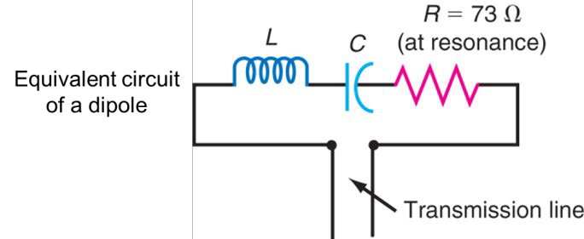• At the resonant frequency, the antenna appears to be a pure resistance of 73 Ω

Dipole Antenna gain (*G*)

• A dipole antenna gain is 1.64

• A half-wave dipole antenna has a power gain of 1.64 (or 2.15 dB) over an isotropic source.

• Antenna gain relative to a dipole antenna can be expressed in decibels as **dBd**.

• Thus, an antenna with a gain of 3 dBd would have a gain of 5.15 dBi (3 dB + 2.15 dB)

Dipole Antenna Lengths

• A dipole resonates best when it is approx. 95% of the actual “half-wavelength length”

• Shortcut:

Lfeet = 468/f MHz (This is in Feet)

• 1 ft = .3048 m

• Dipole hung vertically is closest to an isotropic radiator

• Bottom of dipole antenna should be at least ½ a wavelength off the ground

o May make total structure height unreasonable

Conical Antenna

• A common way to increase bandwidth is to use a version of the dipole antenna known as the conical antenna.

• The center radiation resistance of a conical antenna is much higher than the 73 Ω usually found when straight-wire or tubing conductors are used.

• The primary advantage of conical antennas is their tremendous bandwidth.

• They can maintain a constant impedance and gain over a 4:1 frequency range.

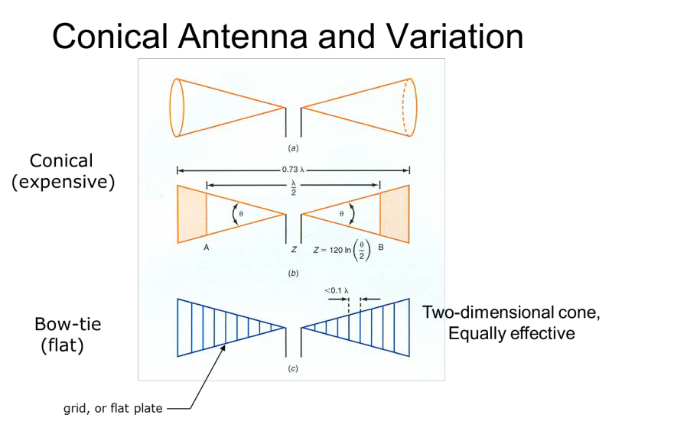

Antenna Beam Width

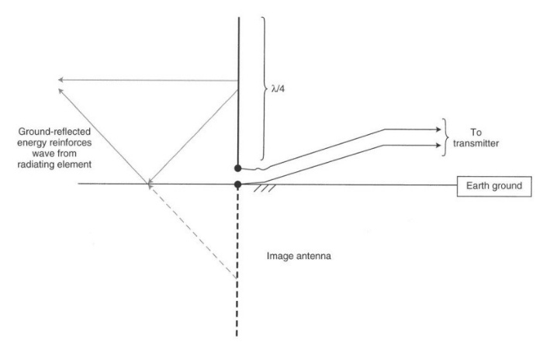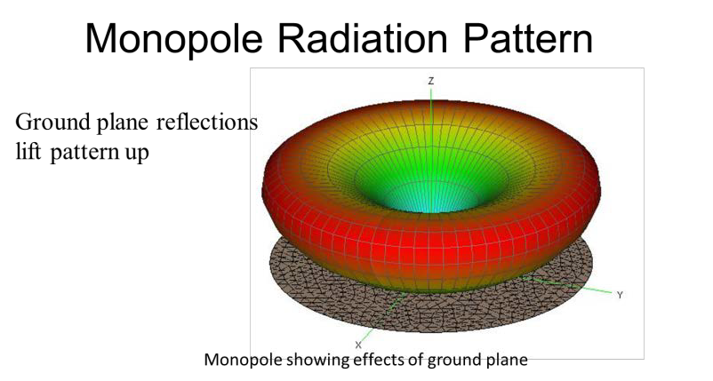

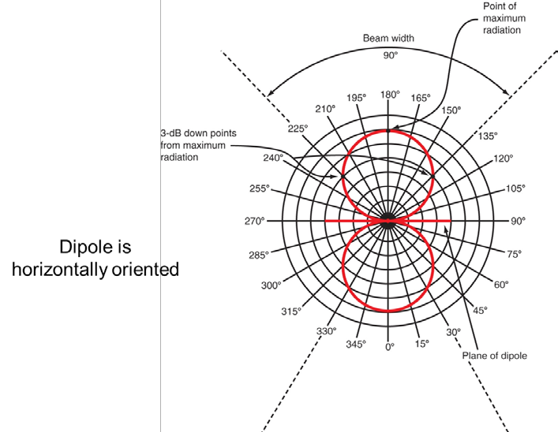

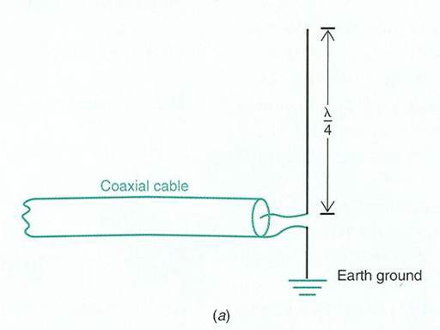Marconi or Ground-Plane Vertical Antenna

• The quarter-wavelength vertical antenna, also called a

Marconi antenna is widely used.

• It is similar in operation to a vertically mounted dipole antenna.

• The Marconi antenna is half the length of a dipole antenna.

• The earth acts as a type of electrical “mirror,” effectively providing the other quarter wavelength making it equivalent to a vertical dipole.

Marconi Advantages

• Half the length of a dipole

• Can be located at earth level without degrading performance

• Has omni-directional radiation pattern similar to dipole

Marconi Disadvantages

• Gain is slightly lower than a dipole (about 1 dB less), but for our purposes we will consider them the same

• Antenna is extremely dependent on conductivity of the earth

• Using a counterpoise will improve conductivity

Counterpoise

• Sometimes connecting a monopole antenna to the ground is not feasible. Create a ground.

o Antennas mounted on buildings or towers

o Soil is highly resistive (dry)

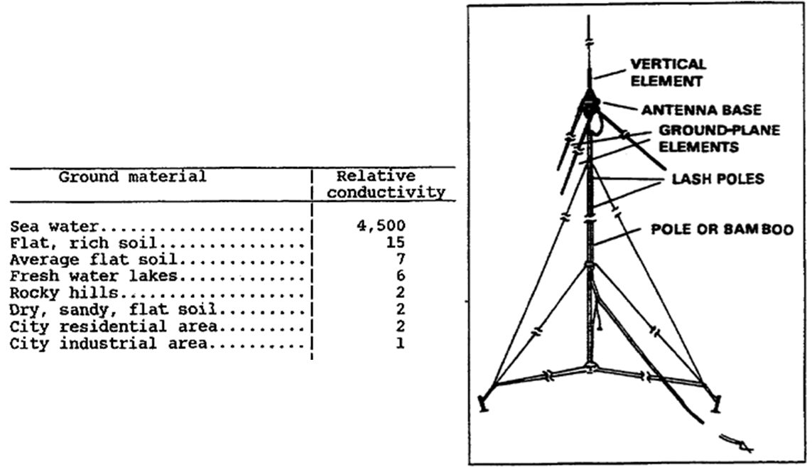

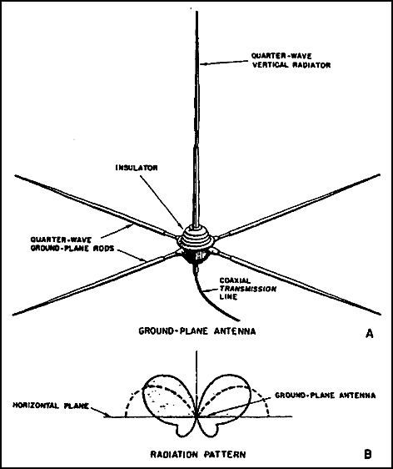• A **counterpoise** is a flat structure of wire or screen that forms an artificial

reflecting surface for the monopole antenna if the actual earth cannot be used

• Counterpoise requirements

o Must be at least equal to or larger than the antenna.

o Should extend in equal distances from the antenna.

o Must be insulated from the ground.

• The performance of a quarter-wave antenna (either well-grounded or using a counterpoise) is essentially the same as a half-wave dipole antenna.

• “Drooping” radials is one way to adjust antenna impedance.